High Performance Door  Rapid Roll® Clean  (High Speed Door) |  | 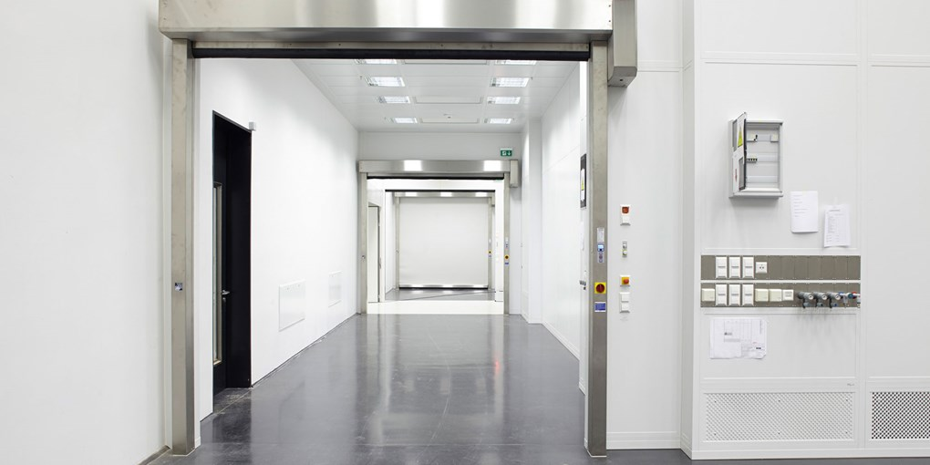
Door type | RR Clean
Description | Certified flexible high performance door, opening in vertical direction, certified for the use in cleanrooms. Compliant to the national norms and regulations in cleanroom applications according to DIN EN ISO 14644-1 and GMP  Certified according to ISO 5 and GMP class C.  Low Particle emission , Low Air Exchange.  Certified by Fraunhofer
Opening/closing speed | 2.0 / 1.0 m/s
Leakage | Max. 20m³/h at a pressure difference of 25 Pa, at a door size of 3 m²
Self-supporting side frames made of stainless steel V2A | Self-supporting side frames max. DW 110 mm, motor cover , top roll cover & bottom profile are in Stainless Steel V2A
Lintel space requirement | 410mm Minimum
Door curtain | Made of PVC with vertical reinforcement stripes in white (similar RAL 9016).
Control system incl. self-opening | Frequency converter control MCC^{VectorControl} with uninterrupted power supply (UPS) for continuous operation in case of power failure. UPS and MCC^{VectorControl} are installed under the top roll cover.  Graphic display and foil keypad for easy operation installed on the drive side.
Safety devices | Pre-running photocell, door line photocell integrated in the side frames, drop down protection in the drive unit
Actuators / Switch | Integrated, contactless actuator mounted on Guide rail / side frame.
Drive unit | Direct Drive Gear motor, mountable left or right
Supply voltage | 3L/(N)PE 380/400/415/440/480V; 50/60 Hz
Protection | IP 55
Control voltage | 24 V DC
Make | ALBANY RapidRoll® Clean
Tender Spacifications

